KASTHURI RAJA.M

 **Education :-**

**2021-Present M.Sc. Computer Science (Data Science and Full Stack)**

RVS College of Arts and

Science -Coimbatore.

**2018-2021 B.Sc. Computer Science**

RVS College of Arts and Science -Coimbatore.

Aggregate of 83%

**2017-2018 HSC**

Century Foundation Matric Higher Sec School-Tirupur.

Aggregate of 68%

**2015-2016 SSLC**

# About Me :-

Looking for opportunity to incorporate my

Century Foundation Matric Higher Sec School-Tirupur.

 **Project :-**

## Portfolio

Aggregate of 84%

skills and training to help the company grow. I am looking forward to roles that will help me realize my potential by exploring the various aspects of this field.

This project is My portfolio - Web Page. It’s my own website. This project contains HTML, CSS and JavaScript. I have added My personal information’s like my skills, My other projects based on Data Science, Other Small Stuffs and my contact details in this project.

+91-96553-44888

Portfolio Link :- [**My Portfolio**](https://kasthuriraja-portfolio.netlify.app/)

[kasthuriraja023@gmail.com](mailto:kasthuriraja023@gmail.com)

# Professional Skills :-

## Full Stack(MERN) Data Science

48, Old Cloth Street, Tirupur - 641604.

[**My LinkedIn Profile**](http://linkedin.com/in/kasthuri-raja-m-327165221)[**My GitHub Profile**](https://github.com/KasthuriRaja023)

# Personal Skills :-

Leadership

MongoDb Express React Node

## Front End

HTML and CSS

# Certification :-

Business Intelligence Using Tabluae

MS Excel

Data Science Using R

Data Science Using Python

Organizing Management Empathy

# Languages :-

Tamil English

AI Summit-2021 Organized by **Woxen University**. Exploring the **Epidemiology** of Coronavirus.

Webinar Based on AI with IOT Organized by **CSI Engineering College.**

**INFOSYS BPM** Skill development Program.

 **Declaration :-**

I hereby declare that the information furnished above is true to the best of my knowledge.

Telugu

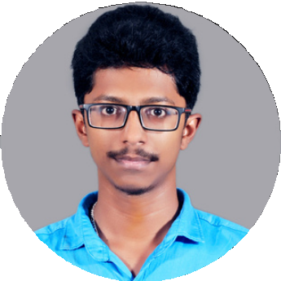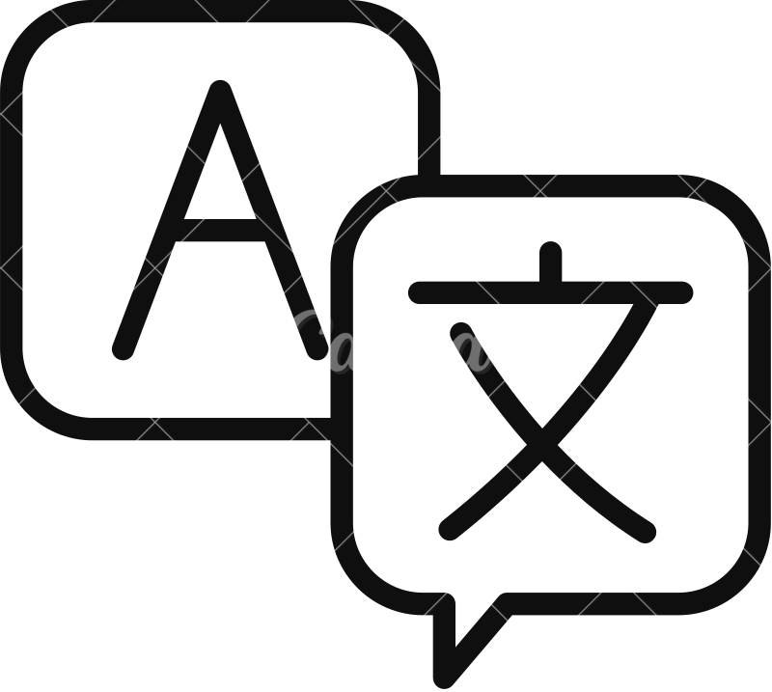

Place :- Date :-

Kasthuri Raja M